**COAL LAB 05 (LAB TASKS)**

**TASK 01:**

**CODE:**

TITLE Task1 (Test.asm)

INCLUDE Irvine32.inc

.data

arrayB byte 1,5,4,6,2,7

arrayW word 11,55,44,66,22,88

arrayD Dword 'a','d', 'b', 'f', 'e', 'c'

.code

main proc

mov al, [arrayB+5]

mov al, [arrayB+3]

mov al, [arrayB+1]

mov al, [arrayB+2]

mov al, [arrayB+4]

mov al, [arrayB]

mov bx, [arrayW+10]

mov bx, [arrayW+6]

mov bx, [arrayW+2]

mov bx, [arrayW+4]

mov bx, [arrayW+8]

mov bx, [arrayW]

mov ecx, [arrayD+12]

mov ecx, [arrayD+16]

mov ecx, [arrayD+4]

mov ecx, [arrayD+20]

mov ecx, [arrayD+8]

mov ecx, [arrayD]

call DumpRegs

exit

main ENDP

END main

**OUTPUT:**

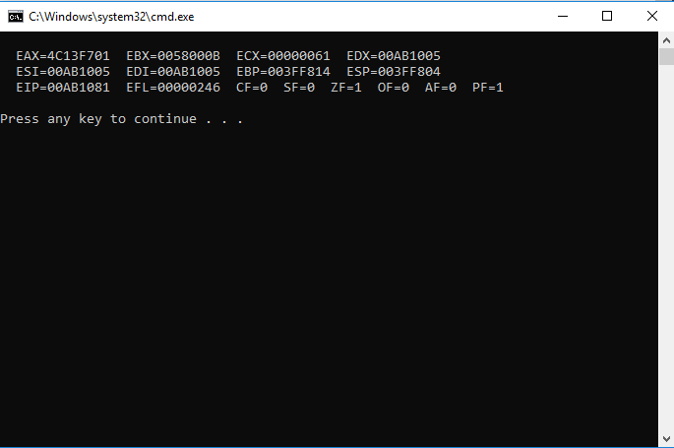

**HAND WRITTEN:**

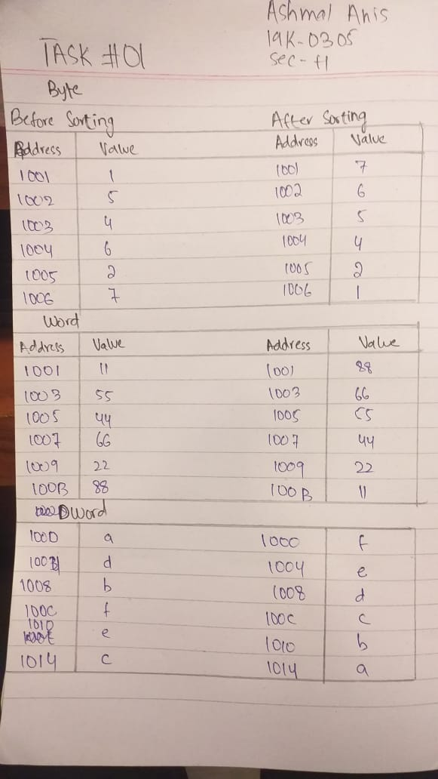

**TASK 02:**

**CODE:**

TITLE Task2 (Test.asm)

INCLUDE Irvine32.inc

.data

arrayB BYTE 010h, 020h, 030h

arrayW WORD 050h, 0100h, 0125h

SUM1 Dword ?

SUM2 Dword ?

.code

main proc

movzx eax, arrayB

movzx ebx, arrayW

add eax, ebx

mov SUM1, eax

movzx ebx, [arrayB+1]

movzx ecx, [arrayW+2]

add ebx, ecx

mov SUM2, ebx

call DumpRegs

exit

main ENDP

END main

**OUTPUT:**

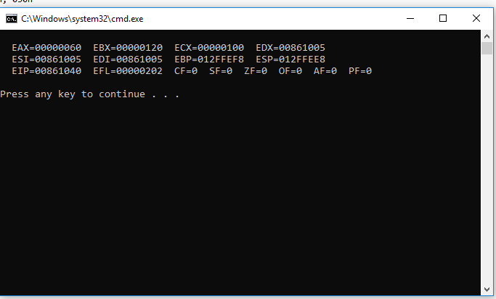

**TASK 03:**

**CODE:**

TITLE Task3 (Test.asm)

INCLUDE Irvine32.inc

.data

arrayB BYTE 10, 20, 30

arrayW WORD 150, 250, 350

arrayD DWORD 600, 1200, 1800

MUL1 DWORD ?

MUL2 DWORD ?

MUL3 DWORD ?

.code

main proc

movzx eax, arrayB

movzx ebx, arrayW

mul ebx

mul [arrayD]

movzx eax, [arrayB+1]

movzx ebx, [arrayW+2]

MUL ebx

MUL [arrayD+4]

movzx eax, [arrayB+2]

movzx ebx, [arrayW+4]

MUL ebx

MUL [arrayD+8]

call DumpRegs

exit

main ENDP

END main

**OUTPUT:**

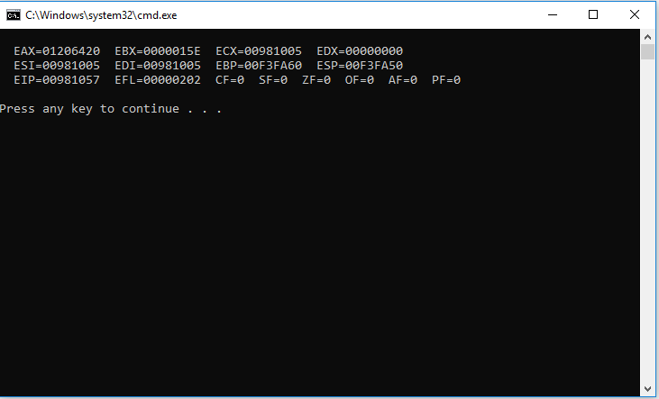

**TASK 04:**

**CODE:**

TITLE Task4 (Test.asm)

INCLUDE Irvine32.inc

.data

A WORD 5

B WORD 12

Z WORD 2 ; unable to initialize it with C (error)

D WORD 13

E WORD 8

F WORD 14

VAL WORD ?

.code

main proc

MOV AX, A

MOV BX, B

MUL BX

ADD AX, Z

MOV DX, AX

MOV AX, D

MOV BX, E

SUB BX, F

MUL BX

MOV VAL, BX

ADD AX, DX

call DumpRegs

exit

main ENDP

END main

**OUTPUT:**

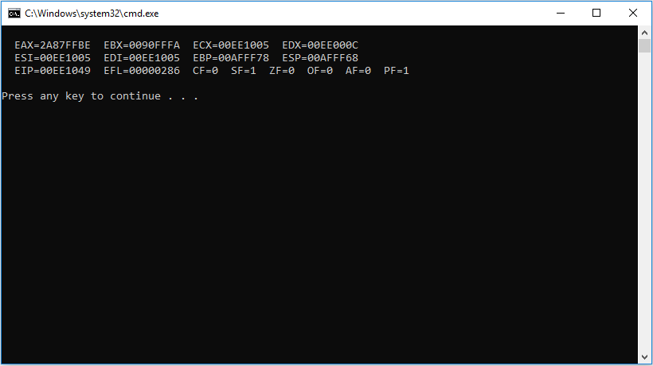

**TASK 05:**

**5.1:**

**CODE:**

TITLE Task5.1 (Test.asm)

INCLUDE Irvine32.inc

.data

X BYTE 10,20,30,40,50,60,70,80,90,100

.code

main proc

MOV ESI, OFFSET X

INC ESI

MOV AL, [ESI]

call DumpRegs

exit

main ENDP

END main

**OUTPUT:**

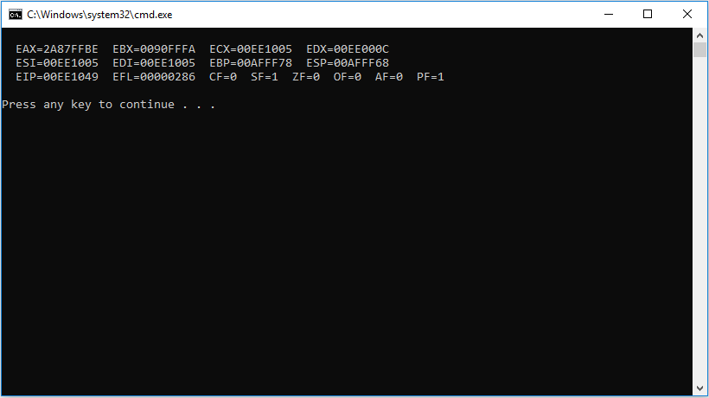

**5.2:**

**CODE:**

TITLE Task5.2 (Test.asm)

INCLUDE Irvine32.inc

.data

X BYTE 10,20,30,40,50,60,70,80,90,100

.code

main proc

MOV AL, LENGTHOF X

call DumpRegs

exit

main ENDP

END main

**OUTPUT:**

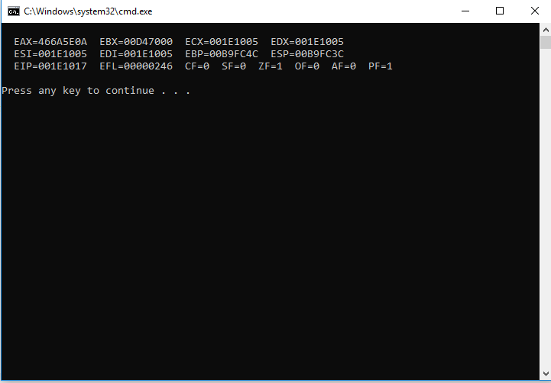

**5.3:**

**CODE:**

TITLE Task5.3 (Test.asm)

INCLUDE Irvine32.inc

.data

X BYTE 10,20,30,40,50,60,70,80,90,100

.code

main proc

MOV AL, SIZEOF X

call DumpRegs

exit

main ENDP

END main

**OUTPUT:**

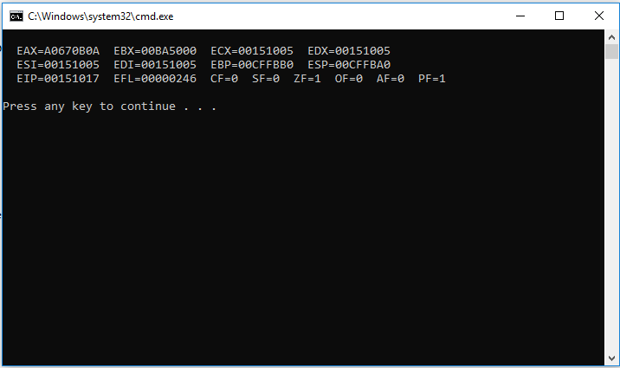

**5.4:**

**CODE:**

TITLE Task5.4 (Test.asm)

INCLUDE Irvine32.inc

.data

X BYTE 10,20,30,40,50,60,70,80,90,100

ALIGN 8

Y BYTE ?

.code

main proc

MOV ESI, OFFSET X

MOV ESI, OFFSET Y

call DumpRegs

exit

main ENDP

END main

**OUTPUT:**

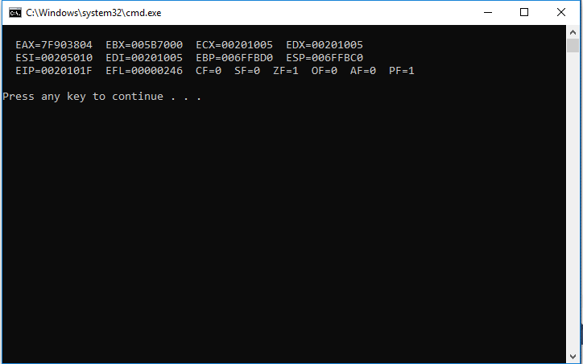

**5.5:**

**CODE:**

TITLE Task5.4 (Test.asm)

INCLUDE Irvine32.inc

.data

X BYTE 10,20,30,40,50,60,70,80,90,100

.code

main proc

MOV AL, TYPE X

call DumpRegs

exit

main ENDP

END main

**OUTPUT:**

